Red Hat JBoss Fuse

BitMoney

Reference Implementation

Technical Documentation

Table of Contents
I - Architecture 3
II – Scope 4
Overview 4
Project Location 4
Requirements 5
Deliverables 5
III - Tentative Timeline 7
Timeline 7

I - Architecture

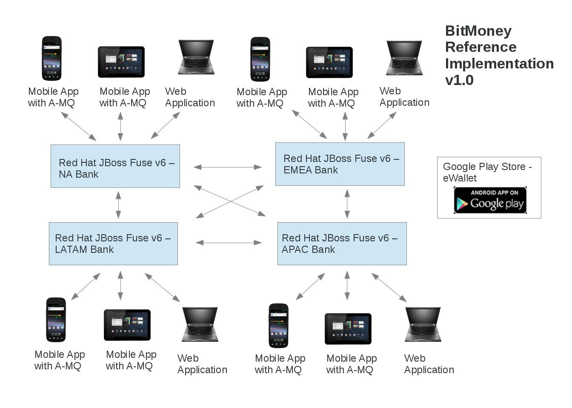

II – Scope

Overview

The JBoss Fuse BitMoney Demonstration Project demonstrates multiple features contained in JBoss Fuse 6.0. The architecture diagram is listed below. The demonstration will use a mobile eWallet and online eWallet application to hold BitMoney with a balance, region location, history, option to allow transferring of BitMoney to another region, option to allow buying of BitMoney and option to allow selling of BitMoney. A initial default wallet value is set as an application property. The regions are LATAM, NA, EMEA and APAC which will be represented by individual Fuse instances. The BitMoney regional banks will maintain total transaction history by user and maintain a exchange rate from BitMoney to region currency and to BitMoney.
The mobile eWallet is an Android application that will use JBoss A-MQ to send transactions to the regional banks (Fuse Instances). For the purposes of the demonstration a Samsung Nexxus S and Motorola Xoom will be used. The online wallet application will be deployed on the JBoss Fuse Instances. The Fuse Instances will also contain the bank application to view transaction and exchange information.
The following components of JBoss Fuse will be demonstrated:
- Apache CXF (SOAP and REST)
[Specific Features Used]
- Apache ActiveMQ
[Specific Features Used]
- Apache Camel
[Specific Features Used]
- JBoss Fabric
[Specific Features Used]
- JBoss Developer Tooling
[Specific Features Used]

Project Location

The project can be found at:
- Code Repository: https://github.com/kpeeples/jboss-fuse-bitmoney-demo.git
- Brief Requirements: https://github.com/kpeeples/jboss-fuse-bitmoney-demo/wiki/requirements
- Project Tracking: https://redhatjboss.teamworkpm.net/projects/40885/overview

Requirements

The following project milestones have been defined and outlined in the requirements:
- eWallet Application – Build Mobile eWallet application. Build Online eWallet Application. Build Message Routes and Web Services. Build test cases. Deploy and Test applications. Update Github and Project tracker.
- Bank Application – Build bank instance and tracking/exchange application. Build test cases. Deploy and Test application. Update Github and Project Tracker.
- Final project demo delivery - Demo fully functional demo showcasing the components listed above. Fully documented project setup for replicating this demo. Full round trip with JBDS, unit testing and documentation.
Each milestone will be outlined in the planning section of the project, will include details on unit tests, integration with JBoss Developer Studio, applications, A-MQ, Fuse, details on project setup and documentation requirements.

Deliverables

- Documentation –
  - An architecture document is required detailing the architecture of the reference implementation and its components.
  - A Getting started document is required which highlights how to install/configure the demonstration and how to run the demonstration
- Source on Github -
  - The source code for the Android, Web Application, Configurations, Settings, etc will be stored on the github link noted above
  - All documentation and presentations will be saved in the repository as well
- Application on Play Store -
  - The eWallet Mobile application will be available for download from the Google Play store
- Demonstrations -
  - A status update demonstration to the Red Hat and SRC Project Teams will be done on or around May 17 and May 31
  - A demonstration virtual event internal to Red Hat to Red Hat Product Managers, Marketing Managers, Solution Architects, Consultants, etc will be scheduled for the end of June to be performed by the Red Hat and SRC team
  - A demonstration virtual event external to Red Hat

III - Tentative Timeline

Timeline

May 17, 2013 – Status Update
May 31, 2013 – Project delivery
June 21, 2013 – Final Code Review comments by committee
June 28, 2013 – Virtual Event for Internal Red Hat
July 26, 2013 – Virtual Event or Webinar external

